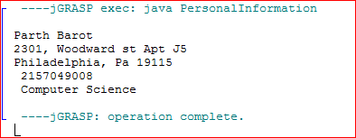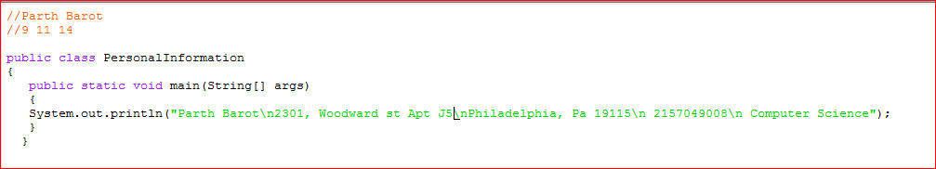**Programming challenges problem 3 Input and output**